**Reset # root user password forgotten in RHEL / CentOS 7**

In this session you will learn how to reset forgotten root password in simple steps

If you know the password already and want to change or reset your password it’s all you know that resetting password using #passwd command to complete the resetting process

This article for forgotten #root password users

Step1 – start the linux server and press “e” to edit the selected item to

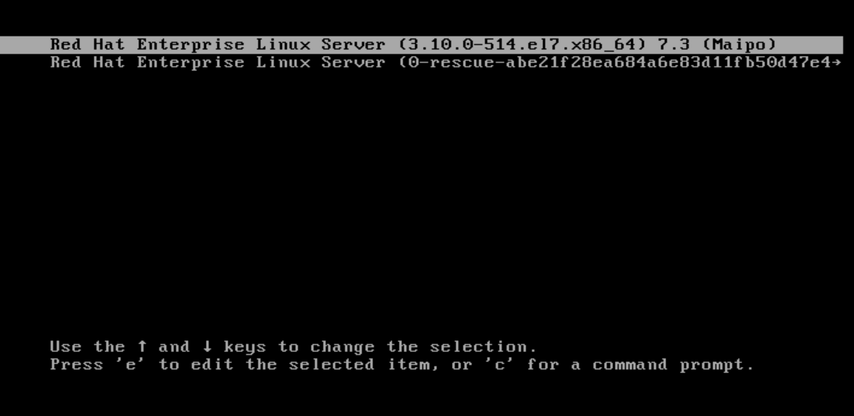

On edit of boot config file find linux16 keyword line at the end of the line append the following keywords without double quotes – “rd.break” observe the below image

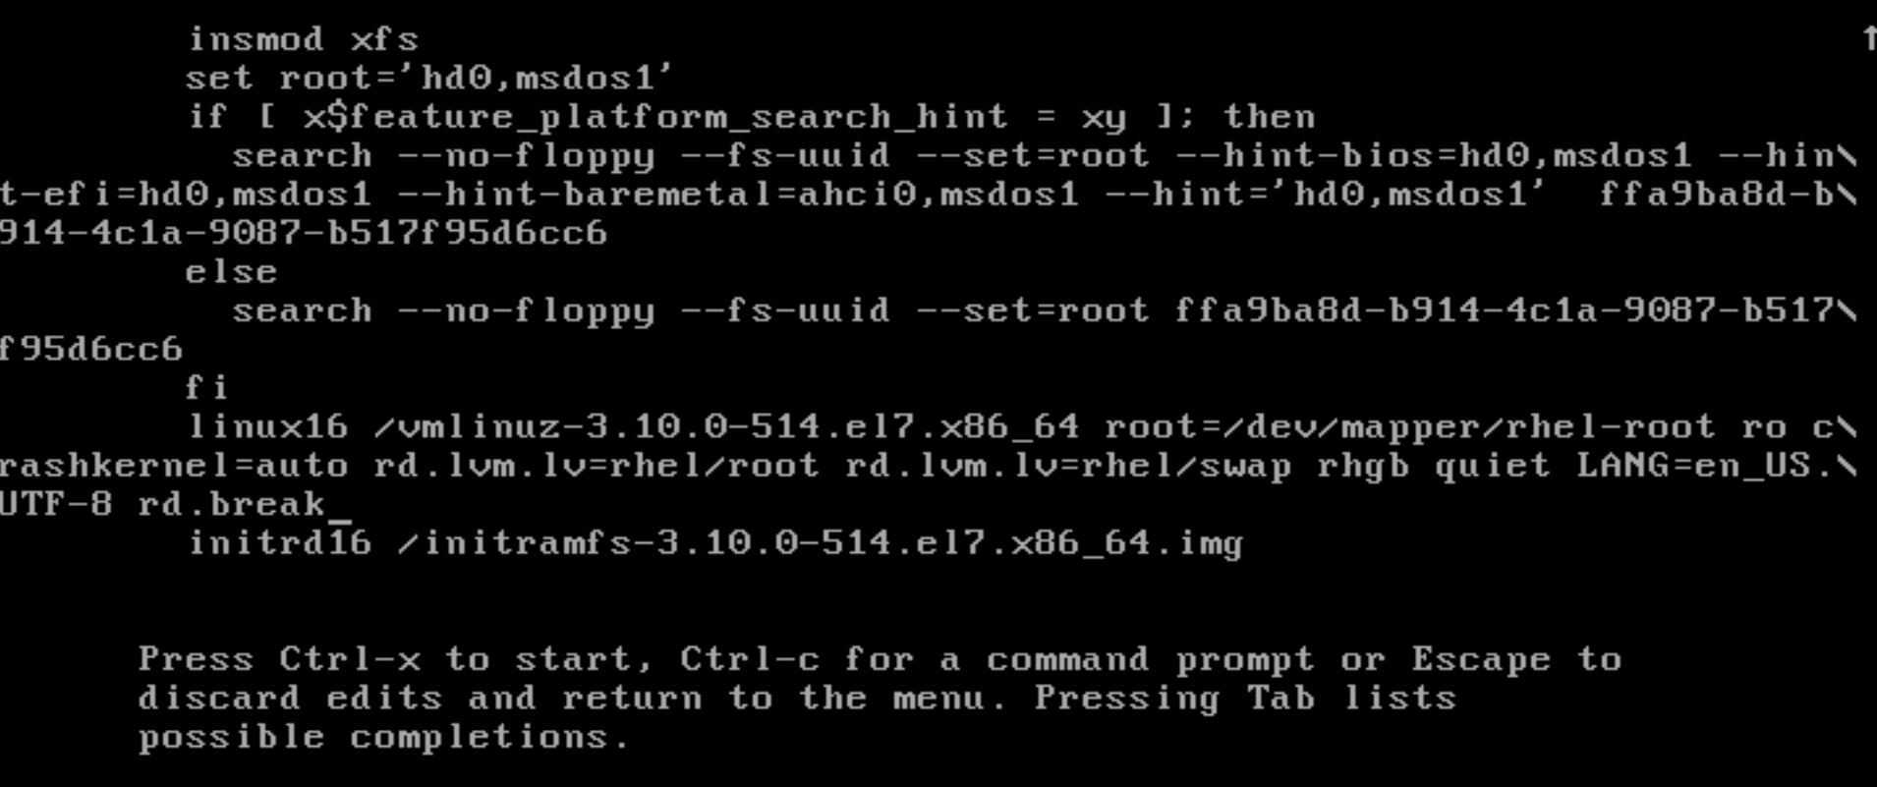

Now press Ctril-x to start the process

Now you will entering emergency mode to reset the root password operations the following screen

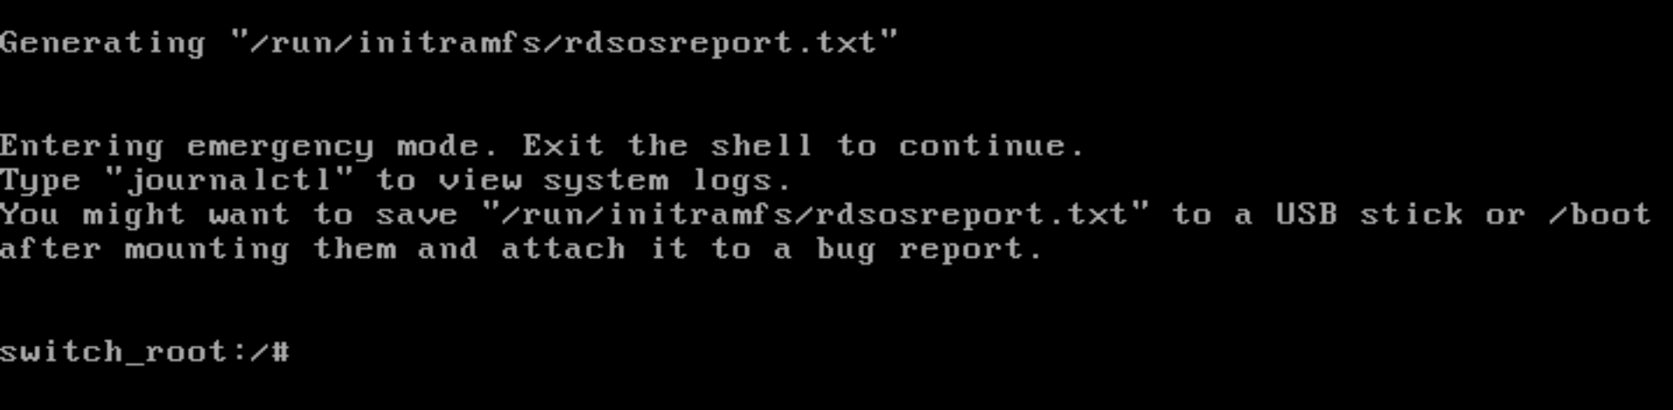

By default /sysroot folder will have an read-only mode, in order to change any modifications Enter the following command to change the real-only permissions to read-write permissions granting and re-mounting to control the /sysroot events

This screen shows how to enter command

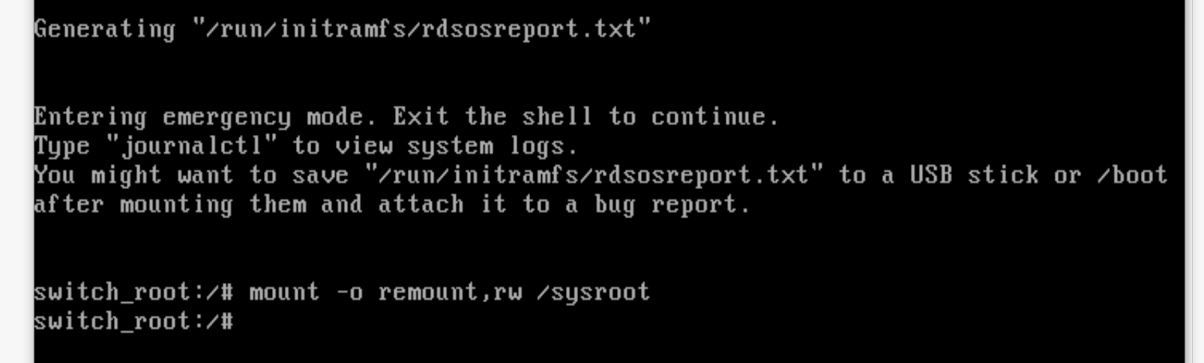

Once the remounted the file system we need to chroot to control with root user for this we need to enter the following command # chroot /sysroot

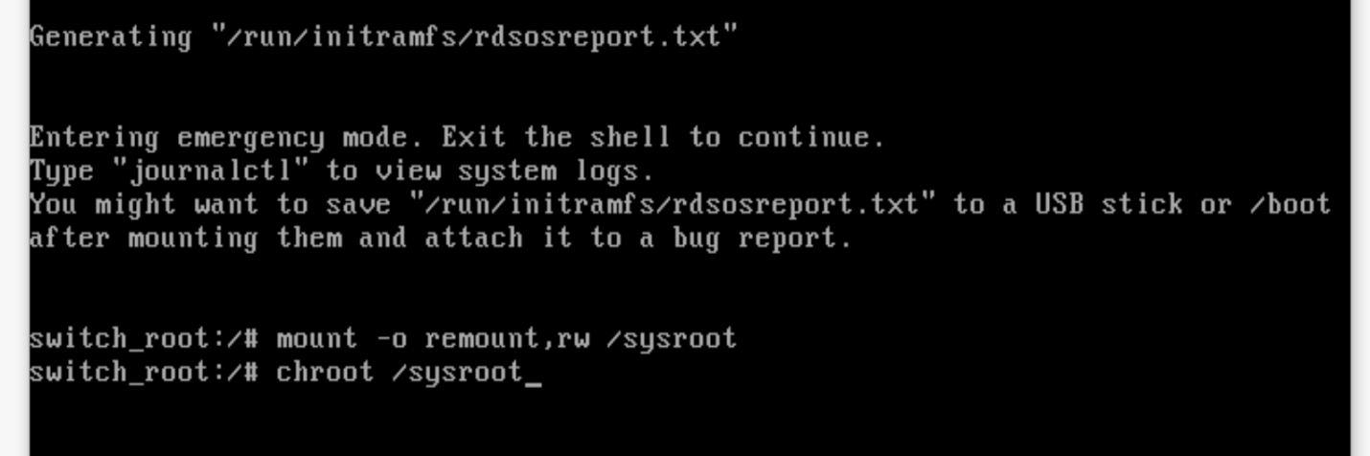

On shell prompt use “passwd” command to change the password now

Clear details described below image

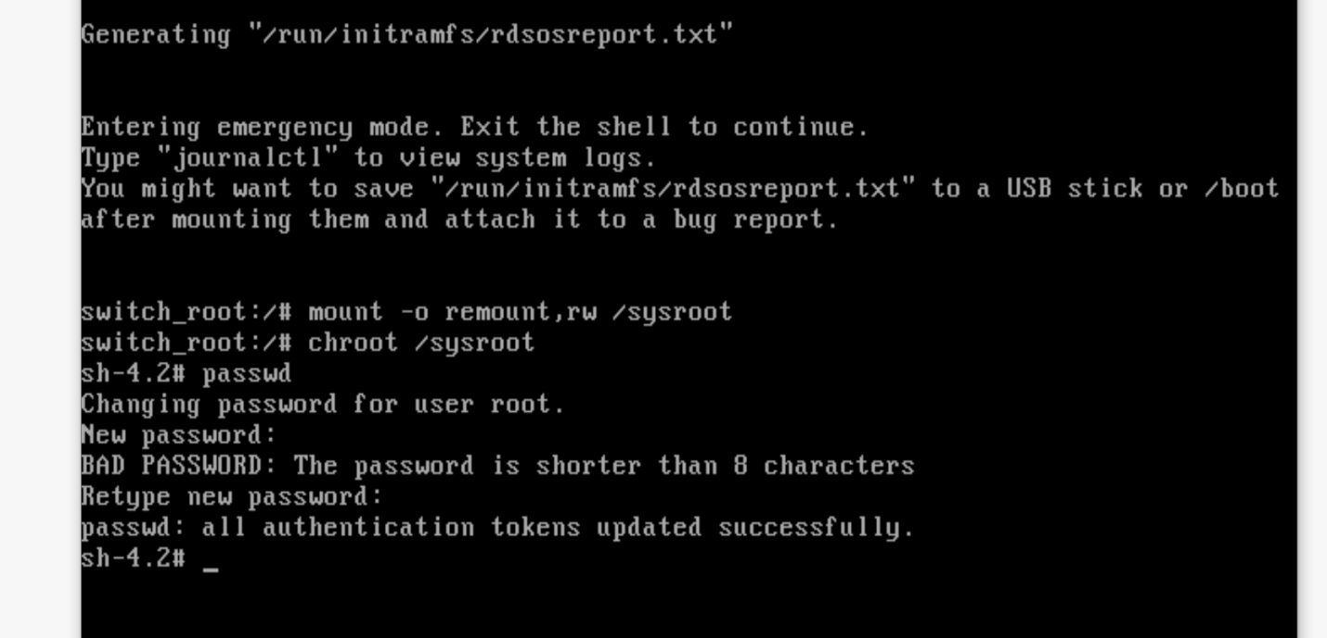

Once it is completed now you need to press #exit and #exit twice to reboot the Linux machine and everything is fine now, if you are using SELinux in your environment and or by default RHEL / CentOS 7 use SELinux in enforcing mode, so we need to fix the file of /etc/shadow file. Here in this mode SELinux will not run and this file will not created by default, which can be problem once we rebooted system without updated this file. We have a command to update/re-create this file using the following command /.autorelabel command using “touch”

By creating this file will automatically perform a relabeling of all file which are require on next boot. Here note this point it make some time depending upon the amount of files you have on

File system. For example it takes me about 2 minutes to complete

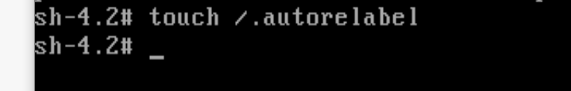

Now “exit” command twice, first one will exit from chroot and second will exit the initramfs root shell and reboot the system

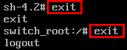

Below screen shows relabeling

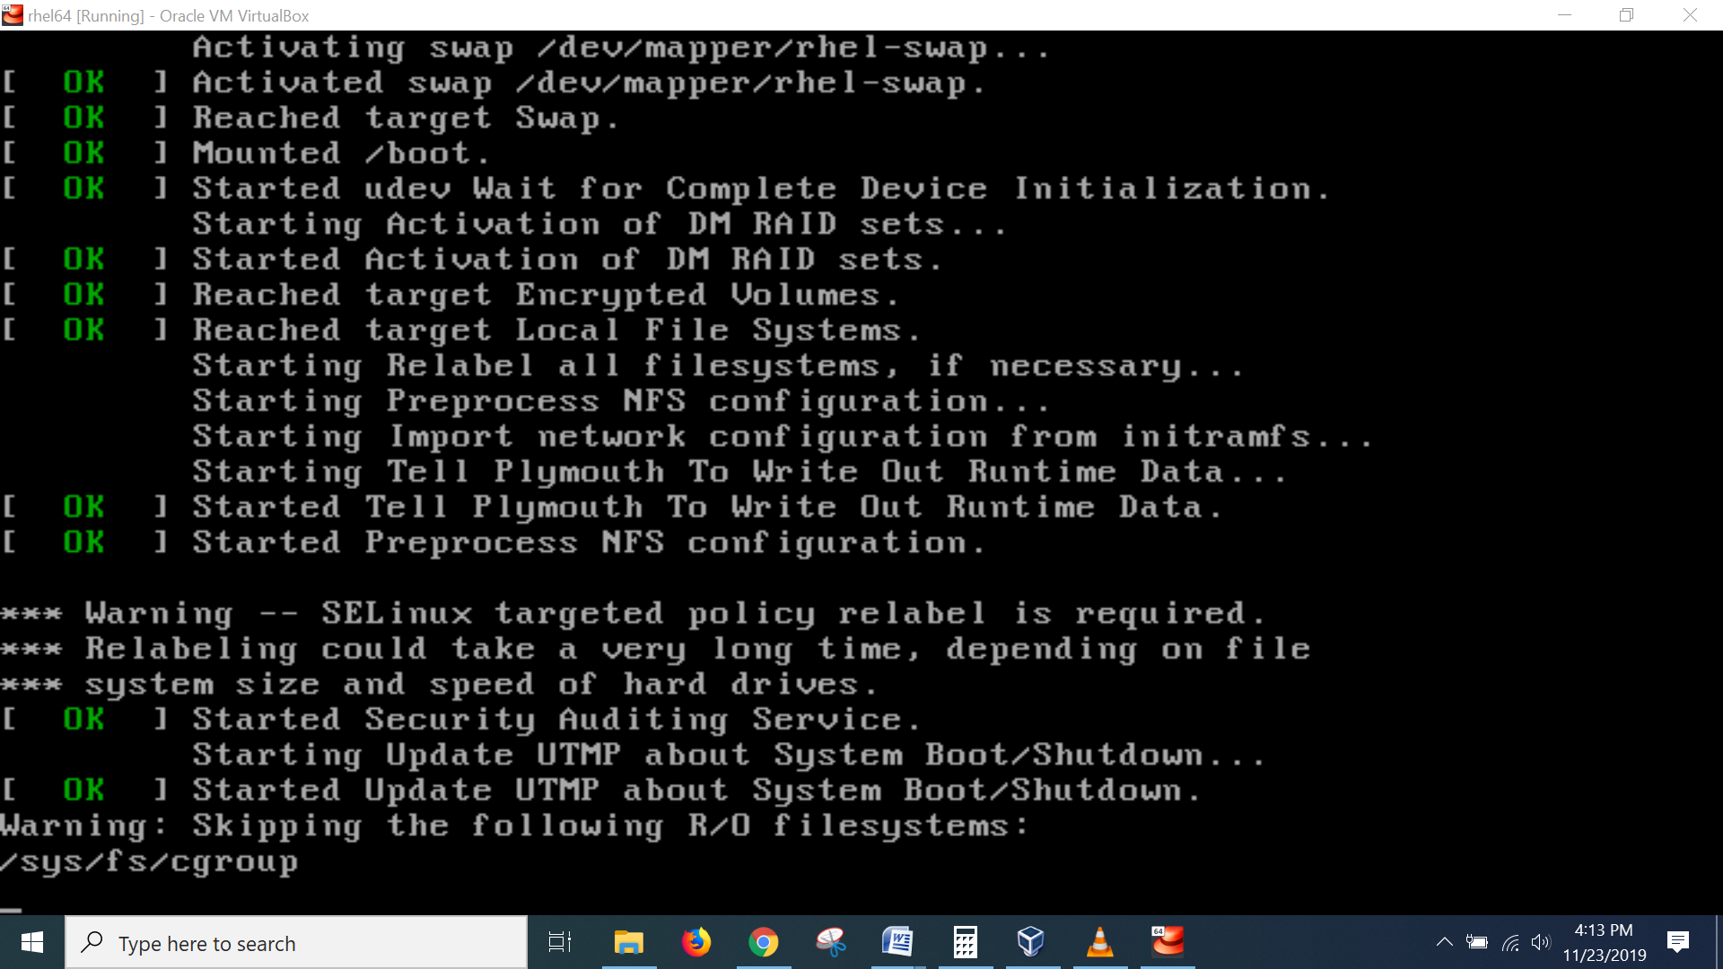

Once the reboot is completed you will be able to login use the root account with your newly set password.

Summary

In this session we learn How to reset root password in CentOs / Linux 7 by booting with the ‘rd.break’ option and remounting the file system with read/write permissions, executing the passwd command to setting newly password to root user finally fixing the SELinux tasks to overcome the security issues to boot linux server.

Is all set reboot the system you will find the relabeling will be display the message above screen I have placed here to display demonstration it may take few minutes depends upon the your system configuration, now you can easily use newly set password of root user login, take backup wherever you require and use it.